SONAR QUBE CODE QUALITY REPORT

BEFORE
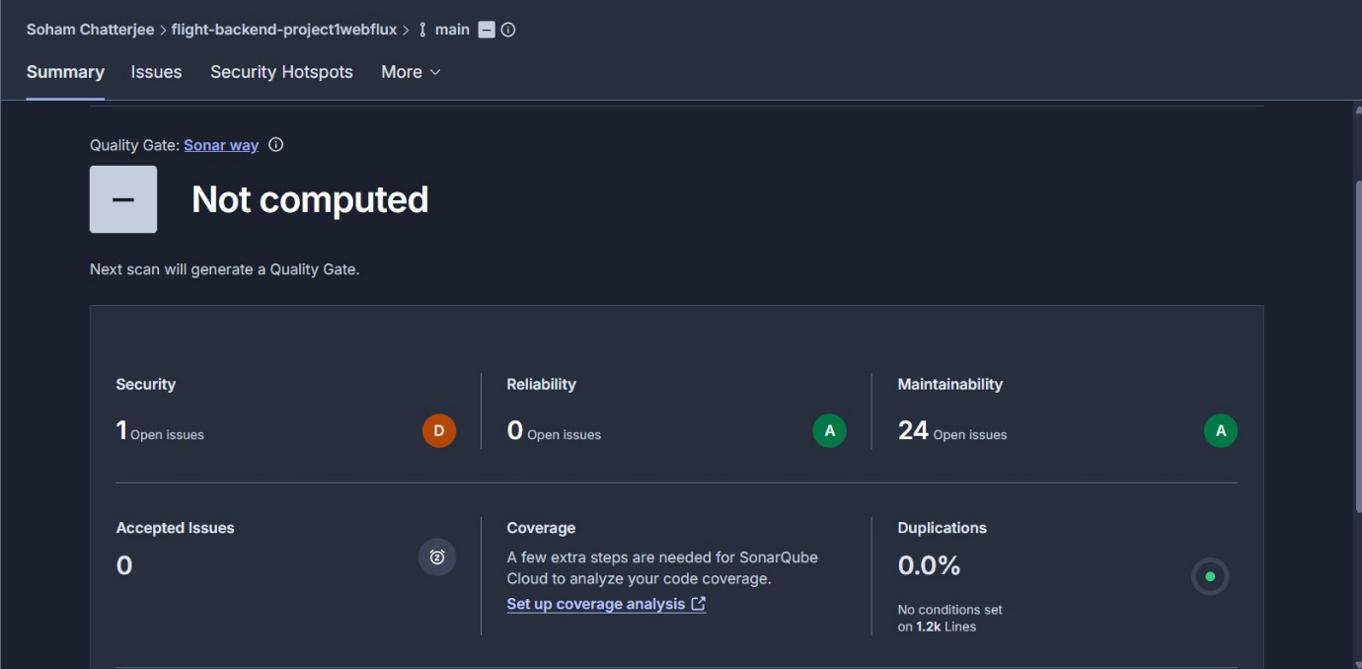

AFTER
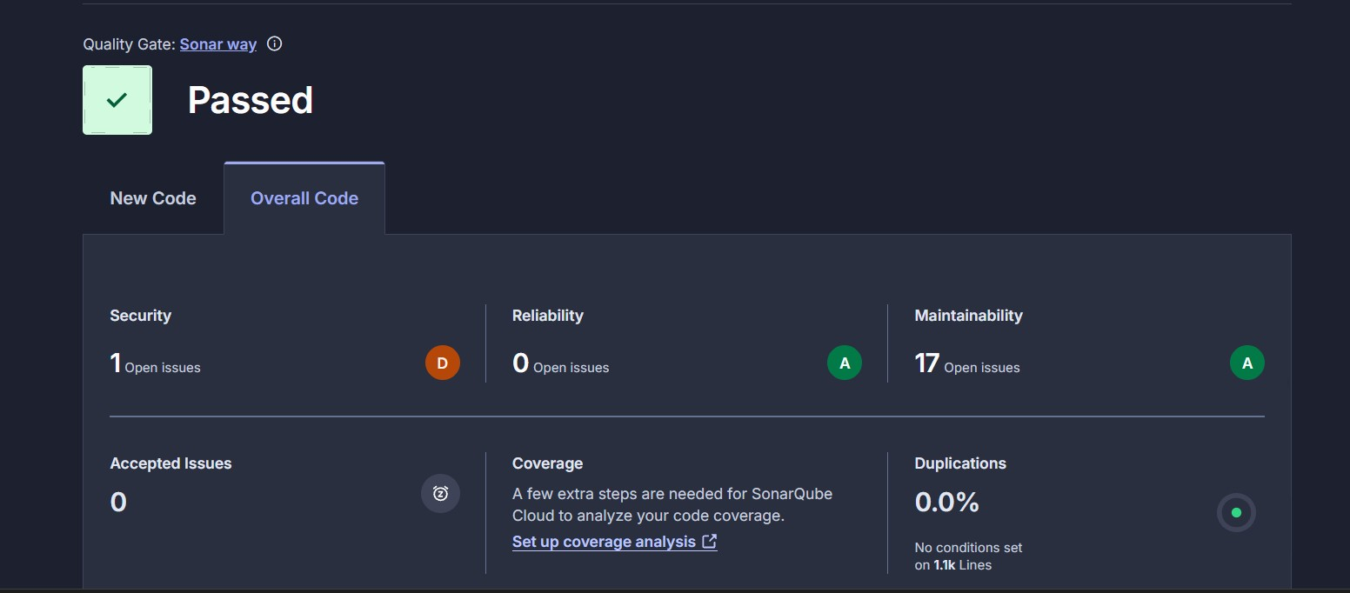
The security issue persist from the use of Airline entity object directly. Issue will be patched with Airline DTO in further updates.

